**University of Engineering and Technology**

**Facilities:**

Complete view of uet can be seen through multiple pictures Complete view of uet can be

* Lecture Halls
* Computer Labs
* Libraries

Seen through multiple pictures Complete view of uet can be seen through multiple pictures

A brief description of Computer Science and Engineering Department is here.

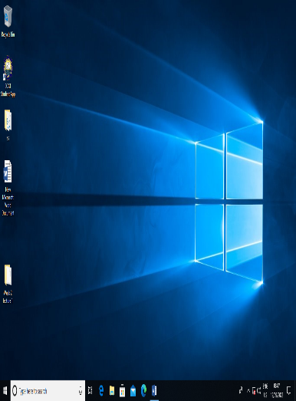

**Degree Features:**

* Bachelors
* Masters
* M.Phils
* PhDs

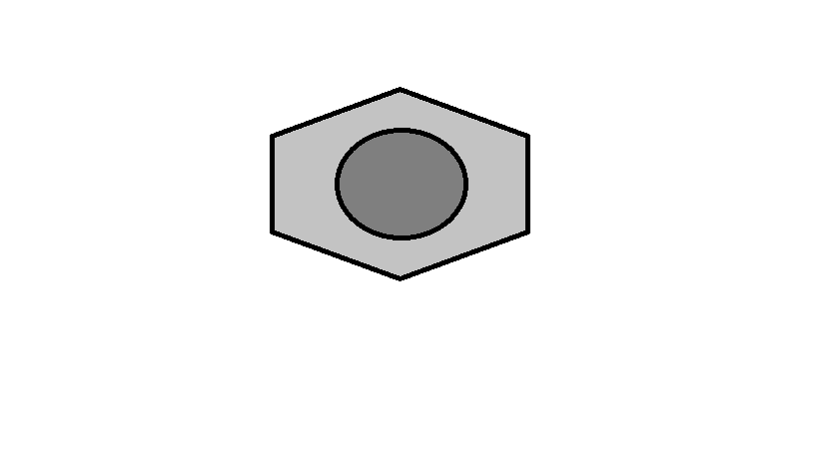 Excellent degree values with going to abroad facilities. Excellent degree values with going to abroad facilities. Excellent degree values with going to abroad facilities.

Complete view of uet can be seen through multiple pictures which are attached below:

**Research:**

**Labs**

* Computer labs
* Robotic labs
* Workshops

“With latest technology for our students”

**Faculty:**

* Mam Amina
* Sir Jawad
* Sir Ali
* Mam Sara

“*PhD Professors with experience of more than 15 years! “*

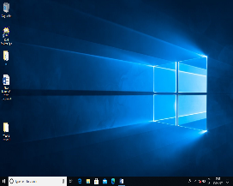

**Introduction:**

Complete view of uet can be seen through multiple pictures Complete view of uet can be Complete view of uet can be seen through multiple pictures Complete view of uet.

**Mission:**

Complete view of uet can be seen through multiple pictures Complete view of uet can be Complete view of uet can be seen.

**Programmes:**

* Mechanical Engineering
* Electrical Engineering
* Computer Science
* Chemical Engineering
* Software Engineering